LAB REPORT实验报告
Lab Title | Shortest Path Problems |  |  |  | Lab No. | 06
Stud. Name | 蒋云翔 | Major | CST |  | Class
Student ID | 2022102330 |  | Date | 2023/12/4
Lab description/objectives:
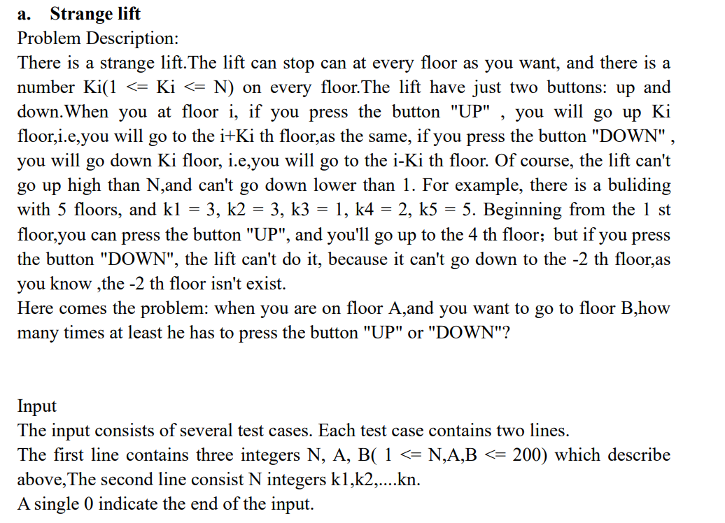
Source code:
#include <stdio.h>
#include <stdbool.h>

#define MAX_N 500

int a, b, x[MAX_N];
bool vis[MAX_N]; //
int q, p; // define head pointer and the tail pointer(Using queue to support bfs)
int N;

typedef struct {
int floor; // The current floor
int dep; // Record the current number of steps
} Node;

Node Q[1000];

int bfs() {
if (a == b) return 0; //situation: Start point equals to the end point
if (a < 1) {
printf("Wrong Start floor!\n");
exit(0);
}
if (b > N) {
printf("Wrong End floor!\n");
exit(0);
}
int ans, top, k;
Q[1].floor = a; // Initialize the data
Q[1].dep = 0; // Initialize the data
q = 1; // Set the head and the tail pointer
p = 2;

while (q < p) {
top = Q[q].floor;
ans = Q[q].dep;

for (int i = -1; i <= 1; i += 2) { // -1 and 1 represents the 2 ways: up or down
k = top + x[top] * i;

if (k >= 1 && k <= N && !vis[k]) {
vis[k] = true;

if (k == b) return ans + 1;

Q[p].floor = k;
Q[p].dep = ans + 1;
p++; // p++ means enqueue
}
}

q++; // q++ means dequeue
}

return -1;
}

int main() {
scanf("%d %d %d", &N, &a, &b);
for (int i = 1; i <= N; i++) {
scanf("%d", &x[i]);
}
printf("%d\n", bfs());
return 0;
}

Program outputs:
Sample input: ↓
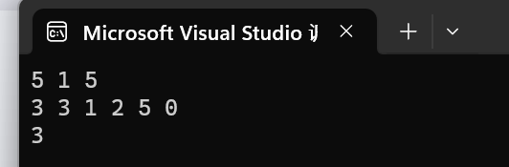
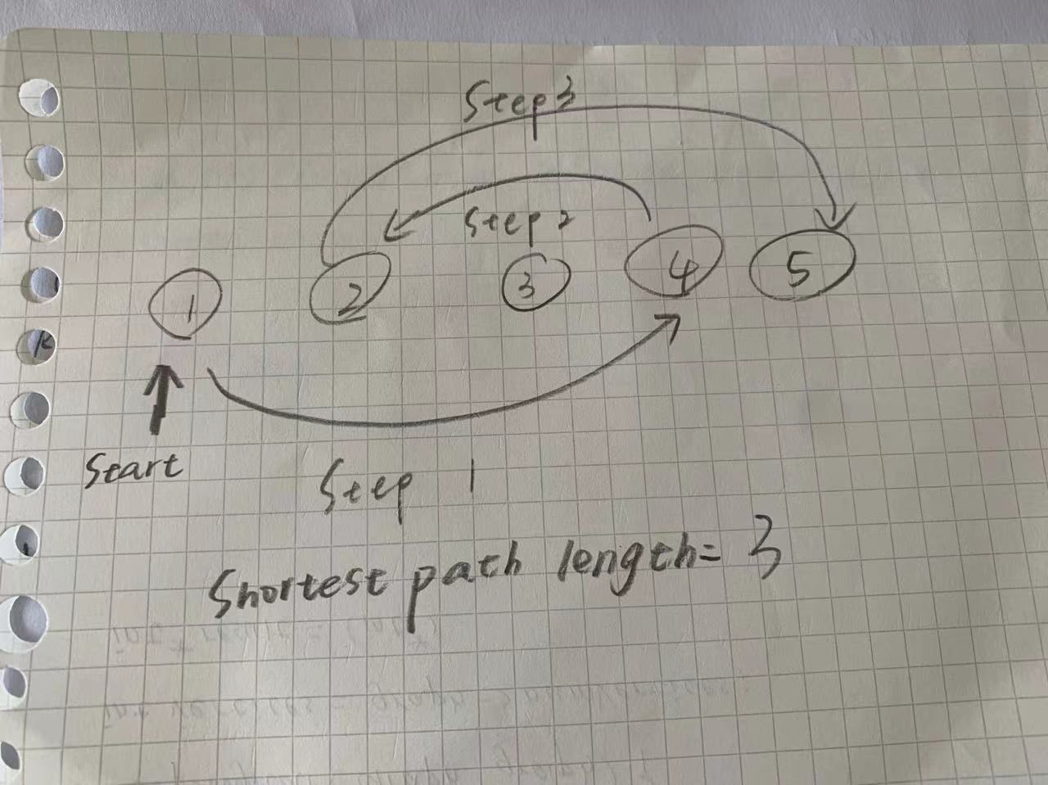

Design case ①: ↓
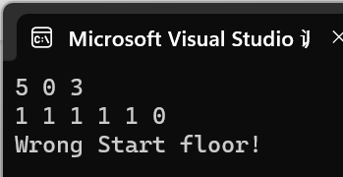

Design case ②: ↓
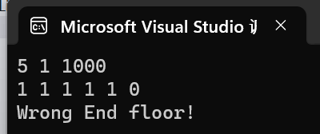

Design case ③: ↓
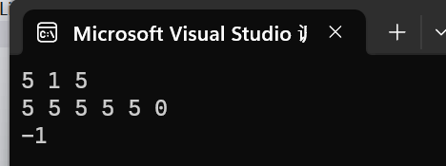

Design case ④: ↓
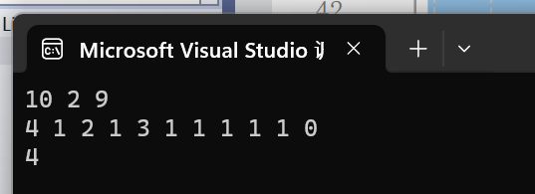
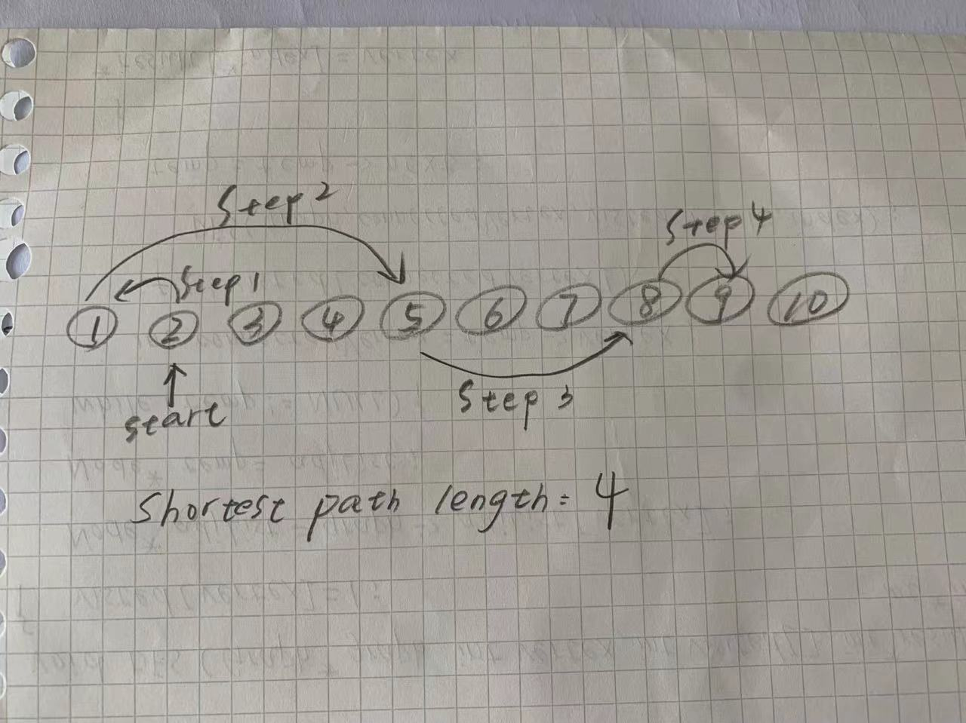

Analysis:
This code is nice for two reasons：
① for (int i = -1; i <= 1; i += 2)
This code makes clever use of the for loop to move the elevator up or down.

② Using the structure of the queue, the head pointer and the tail pointer are designed to jump the elevator floor, and the required number of steps is stored for each floor, and the shortest path is selected for output.

③ Compared with the textbook's unweighted digraph shortest path algorithm, this algorithm is clearer and simpler and is the optimization of the text book’s.

